eFolio – Week 1 and 2
  - Naveen Sellathurai – 33106770

eFolio Task 1.1
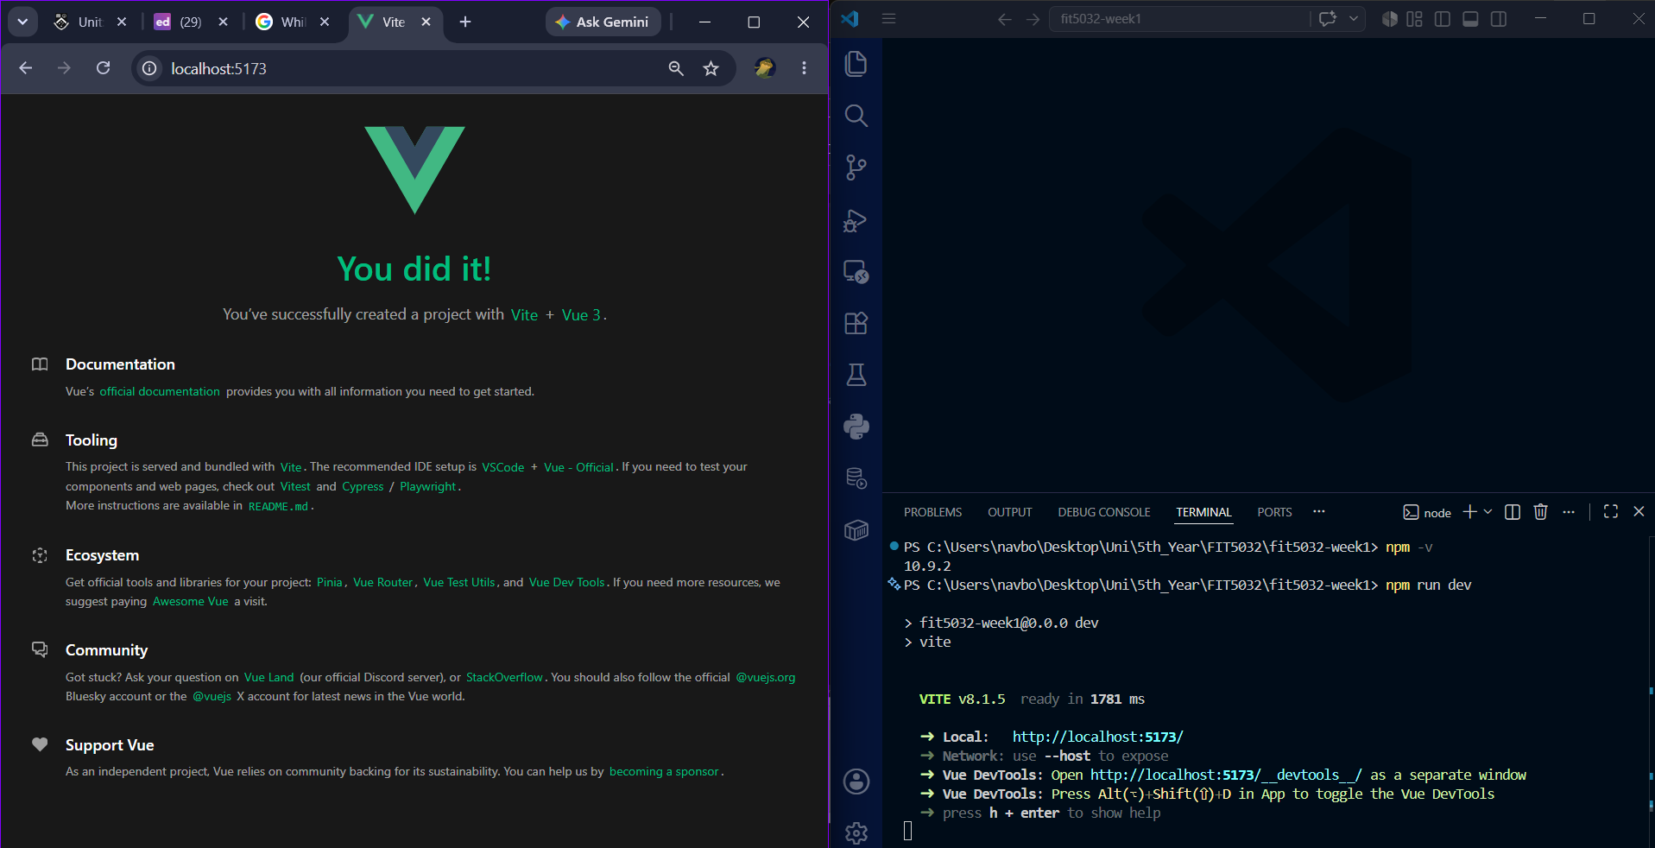

eFolio Task 1.2
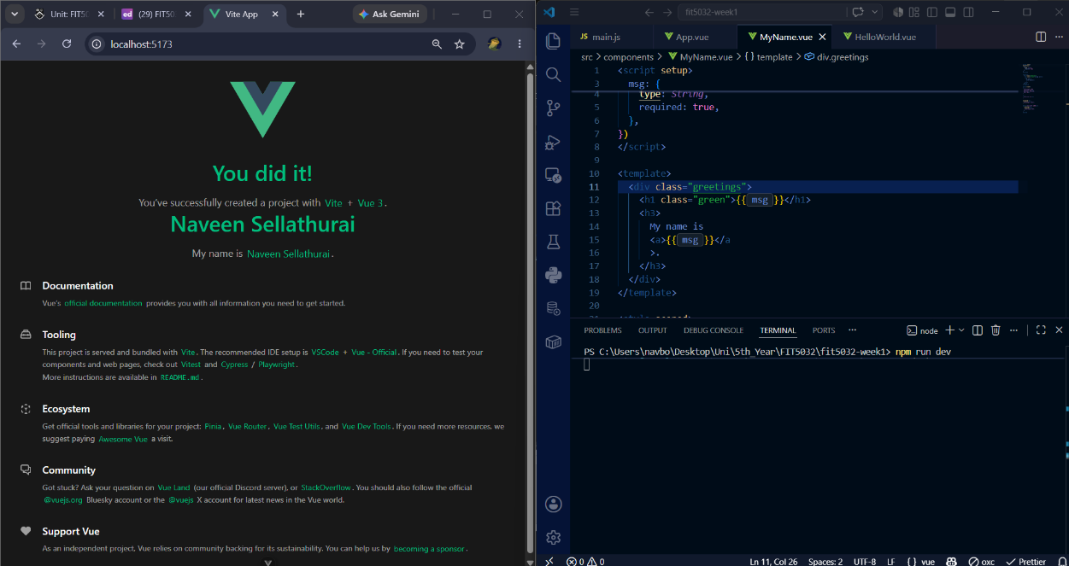
GitHub URL: https://github.com/nsel0009/FIT5032

eFolio Task 2.1
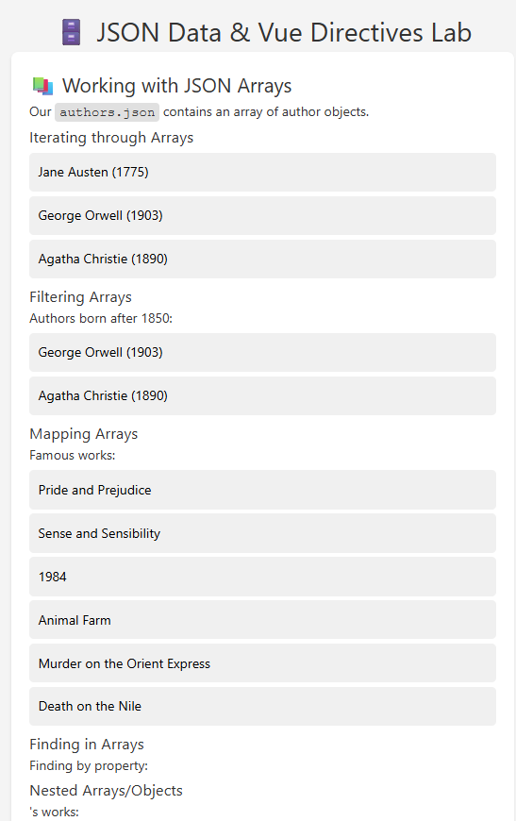
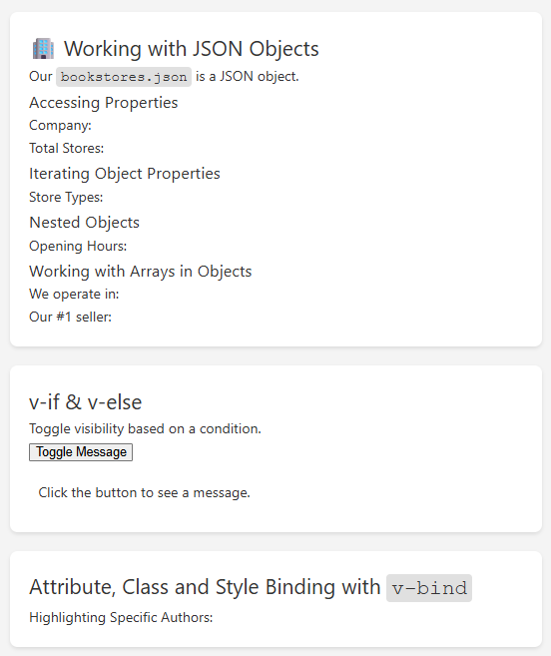

eFolio Task 2.2

